Chapter 1
PROBLEMS AND ITS BACKGROUND

Project Context

Developing a technology for the company’s productivity should be the main concern of the developers. As stated, the state shall give priority to research and development, invention, innovation, and their utilization Online Ticketing System will help the company in terms of tracking the problems, management of request. Online ticketing system will help a lot in the process of company and easily response.

Fortis Technologies Inc, expertise in hardware’s, software’s, and people are value in their proposition, offering end to end solutions to the entire information technology stack. Fortis Technologies focus on emerging and innovative technologies and company’s breadth of integration expertise encourages close cooperation with company’s key technology partners.

The researchers conducted a research and learned that the developers of Fortis Technologies Inc. receives an average of 100 and plus of emails of the technical support team, requesting for support every day. The developer of the company is using g-mail to receive and respond to the e-mails sent by the clients of the company. In the current process of the Fortis Technologies Inc. the developers of the company encountered the problem in monitoring the requested e-mail by the clients. The developers of the company sometimes overlook some emails sent by the clients and some also were ignored. The developers of the company can’t properly manage the received request support; the developers of the company sometimes don’t know that the other developers are also working on the same requested e-mail at the same time. The company encountered these problems because of the current process that the company is using, and if these problems continued the clients of the company may stop their transactions with the company which is the fear of every business or company.

Therefore, the researchers decided to create an Online Ticketing System for Fortis Technologies that will help the business process of the Fortis Technologies. The Fortis Technologies can easily identify the problems and will easily response to the client’s request.

Purpose and Description of the Project

The purpose of creating an Online Ticketing System is to help and enhance the effectiveness of the Fortis Technologies Inc, to easily monitor and identify the technical support requests, issues, status of the ticket. That will increase the technical support requests.

Capabilities of the proposed system:

- The Online Ticketing System can easily track the problem that was requested by their clients and system administrator can easily track or monitor who is assigned in one particular task that the client sent.
- The client can easily check or monitor the status of their requests.
- The client of the Fortis Technologies Inc. can also add comments to the issue for any feedbacks or question.
- The issue will be kept for future reference and will be monitored even if the developers solved the problem.

The target of the proposed Ticketing System is the Fortis Technologies Inc. developers. The beneficiaries of this system are:

- The Company. Online Ticketing System can help the Fortis Technologies Inc. to easily respond to the problem was requested by their clients.
- The Employees. Can easily handle the problems that are being reported by their clients.
- The researchers. Can enhance and improve their skills to resolve and learn about different problem in implementing the system and the proponents are updated on what is happening in the industry.

Objective
This study aims to develop a Ticketing System for Fortis Technologies Inc. to easily track and report the problem progress. Developing a technology for the company’s productivity should be the main concern of the researchers. As stated, the state shall give priority to research and development, invention, innovation, and their utilization have a good service for the clients who will inquire to the website and the services such as support process.

This study has the following specific objectives:
- To design an interface for administrator, users and the clients
- To develop a login/logout module for the users.
- To develop a module for the administrator will be able to monitor and manage easily the reports regarding the technical support request of the clients.
- To develop a module for the user to view and manage technical support request.
- To develop a module for the clients of the Fortis Technologies Inc. that can create and view their requested technical support.

Scope and Limitation of the Project

The proposed project of the researchers is capable of creating issue or technical support requests which will be created by the clients, the clients can also view the progress of the tickets that have been created. The clients can add comments to give their feedbacks on the support of the company.
The users of the system needs to login to access the system, users can view tickets and assign to them solves to fixed the problems. The users can also update the status of the ticket that was assigned to him/her according to the resolution they made.
The administrator of the system is capable of adding, update and deleting of user accounts in the system, the administrator can add, edit and delete in the maintenance module. The administrator also can view the tickets, assign to him/herself or assign to a specific person, the admin can monitor easily do the support team response to the clients, the admin and the users of the system can monitor the statistic of how many tickets they have taken and resolved on the dashboard.

Chapter 2
REVIEW OF RELATED LITERATURE AND STUDIES

Related Literature

According to (Jantti 2013) the literature pertaining to management service desks encompasses the implementation of self-help knowledge management systems.
With this study, this kind of system helps the company a lot especially in monitoring the sales of a particular company or business. It also stated that it also helps the business to have good services that can build a good relationship to the clients.

According to (R. Andriew’s 2011) article entitled “Supporting Your Product how to Provide Technical Support” .she Stated that:

“Users will always need support. You could have a bulletproof product and the most excellent tutorials and documentation, and someone will find a way to break it or just not read the information staring them in the face.”

According to (H. Korth 2011) in “Database System Concepts” the system provided a better alternative that will developed organizational pile handling and management. He stated that;

“The system should produce meaning result quickly. This usually means action reports on an instants, basis or eliminate entirely the traditional historical report, but it does not mean that such reports be supplemented with current action-oriented reports”.

Related Studies
According to (V. Morente 2014) no company can deliver a product or service today without an information technology (IT) component attached to it T. states on an article. “Leaving IT to experts” that,

“When it comes to technology and has been growing fast it’s important to consult or invest to an It infrastructure and technology for maintain the technology.”

According to Johanna Ivarsson (2013) in her case study of an IT Helpdesk service, to solve the service quality issues this study recommends starting to work with measurability and continuous improvements, for example Lean Six Sigma. The IT department can strive to increase the interdepartmental communication, share work tasks, educate internally, document competences and clarify responsibilities to decrease the workload.
This statement influences us why the proponents decided to create a website that will help the company to lessen the workload of the developers.

According to Knapp (2013) consequently, help desks have evolved into service desks. Furthermore, the most critical issues faced by organizations in the service desk environment pertain to: (1) the structure of the service desk; and (2) how to improve user support.
The researcher’s apply this by putting a brief introduction about their service, and influences the researchers to develop more efficient and effective Ticketing System. The researchers added a comment section where the client can able to communicate to the developers of the company.

According to Abdinnour (2011) the virtual service desk became prominent when networking capabilities increased. In the virtual service desk structure, end users get the impression of a single, central service desk when in fact the service desk representatives may be using online.
This statement by Abdinnour strengthens the researcher’s decision and provides a better idea of how the system will look and may give their clients a satisfaction in using the Ticketing System.

Chapter 3
DESIGN AND METHODOLOGY

Requirement Analysis

Start

Report Bug Request

Support

Review Report /
Request

Fix Bug

Verified if bug is fixed

No Yes
Notify Support
Team
Request
Fix

Notify
User

End

Figure 1.0 Flow chart of the current process of the Fortis Technologies Inc.
Figure 1.0 shows the current process of Fortis Technologies Inc. in receiving and responding to the technical support request of the clients.

Requirement Documentation

- Client module - This Create Ticket Module can create ticket that will be use for transaction with the company and View Ticket for clients which will able them to see the progress of the issue they sent.
- Ticket Module – This module enables the administrator and the users to view the open tickets, the assigned tickets, closed tickets and those that are pending. In this module where they make the progress of the tickets.
- Maintenance Module – This module is accessible only by the administrator. In this module the administrator can add, edit and delete status, severity and resolution.
- Users Module – This module is accessible only by the administrator. In this module the administrator can add, edit, and delete user accounts for the system. The administrator also can activate and de-activate the user accounts.
- Reports – This Module was designed to provide a feature-rich and user-friendly web interface for managing reports. The core idea behind the Reporting Module is to provide a solid foundation so that other developers can use the framework to implement new features.

System Design
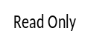
Portal Management

Administrator

D Administrator
WATCHER
View
0
Ticketing System
Get Ticket
Verify bug
Portal Activity
Resolved bug
View, open, close, in progress, pending

Send Support request

Employee

Client
View Request Status

Ticket Information

D

Figure 2.0 Data Flow Diagram of the Online Ticketing System for Fortis Technologies

Development and Testing
The researchers use the iterative methodology in iterative is a process that starts with a developing the project. Iterative is a process that starts with a simple implementation of subset of the software requirements and iteratively enhances the involving versions until the full system implementation. In each cycle or iterations, it allows the research to add more functions for the system and modify the designs

Testing
Design
Build Client Module
Implementation

Requirements

Design

Testing
Implementation
Build Users Module

Figure 3.0 Representation of the methodology use by the proponents

Figure 3.0 Shows the process on how do the researchers developed the proposed project using the iterative methodology.

Description of the Prototype
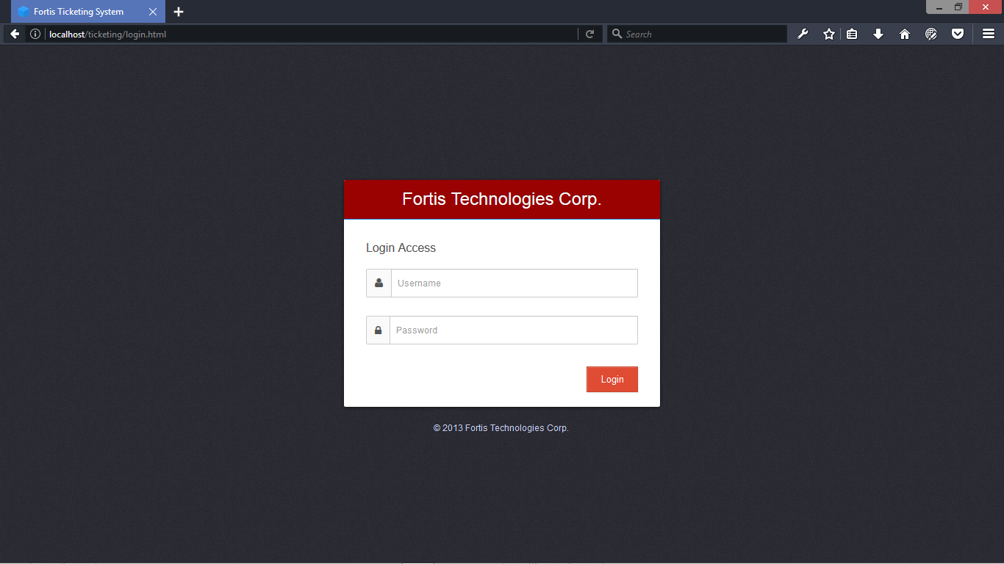

Figure 4.0 Login Form
This page is where the users of the system need to login to access the system.

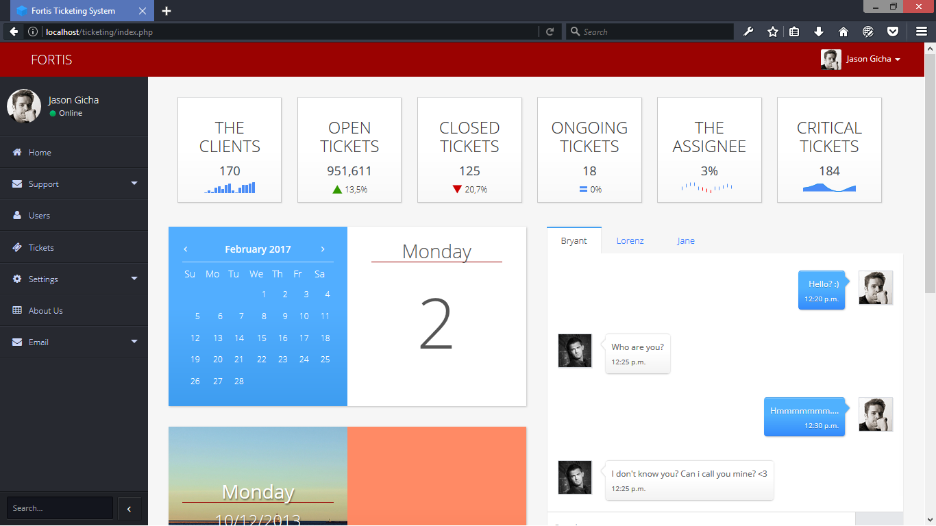

Figure 5.0 Admin Index
This Admin Index module will use to see and to manage the system.
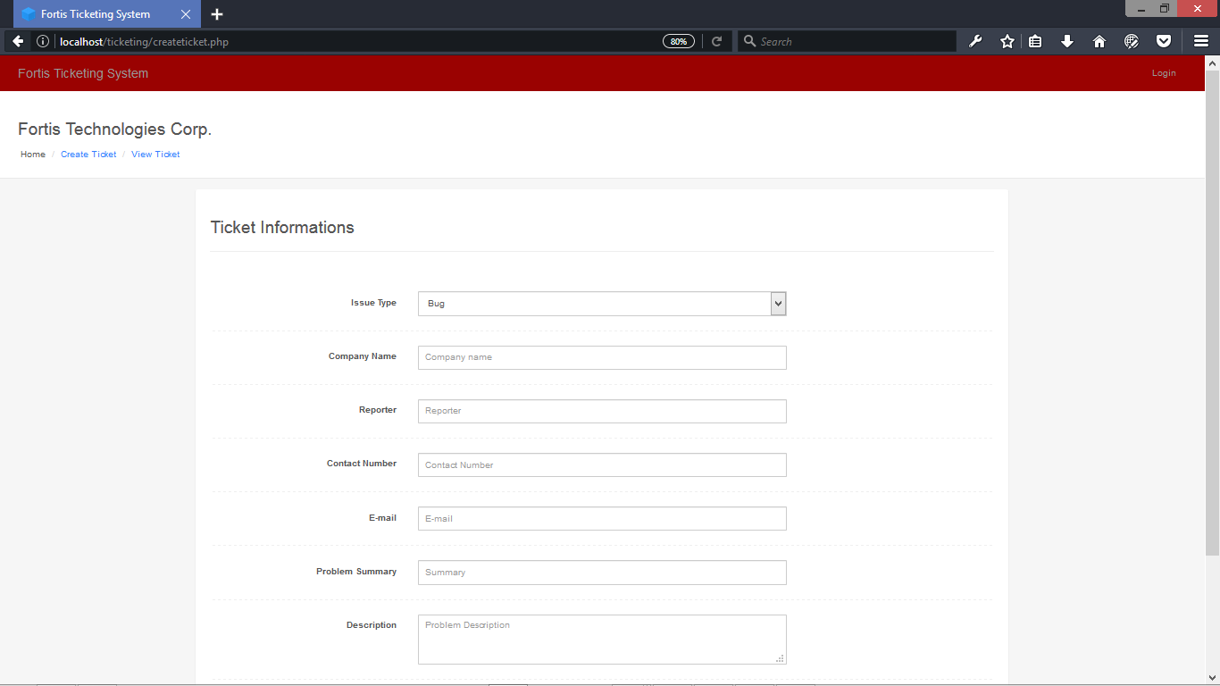

Figure 6.0 Create Ticket
This Create Ticket Module can create ticket that will be use for transaction with the company
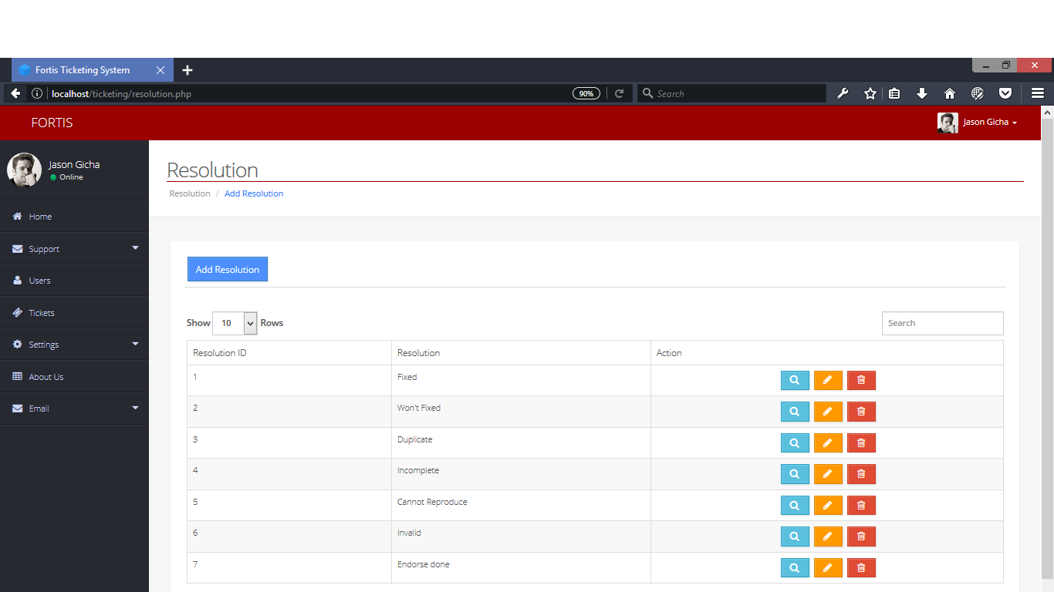
Figure 7.0 Setting Resolution
This Setting (Resolution) Module can add, edit, and delete resolutions.
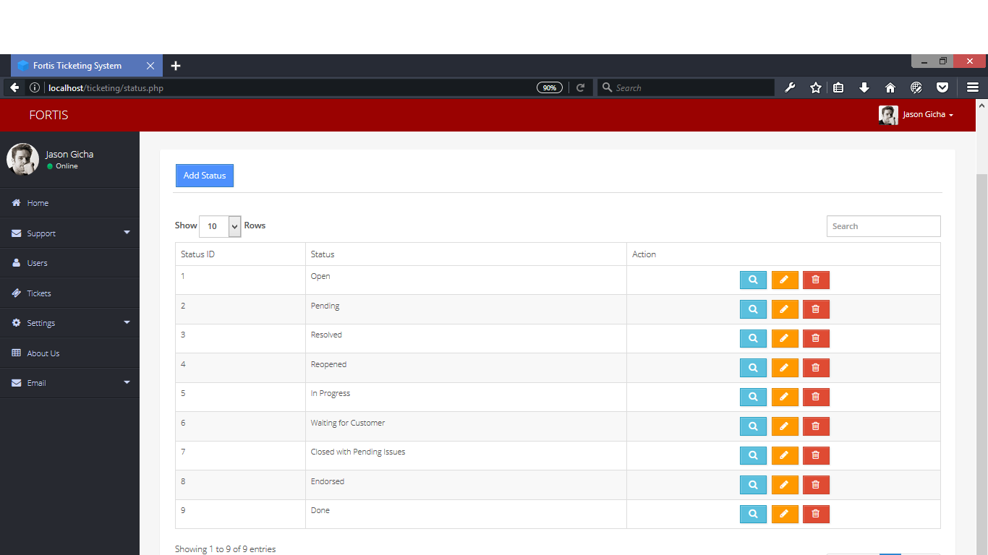

Figure 8.0 Setting Status
This Setting (Status) Module can add, edit, and delete status.

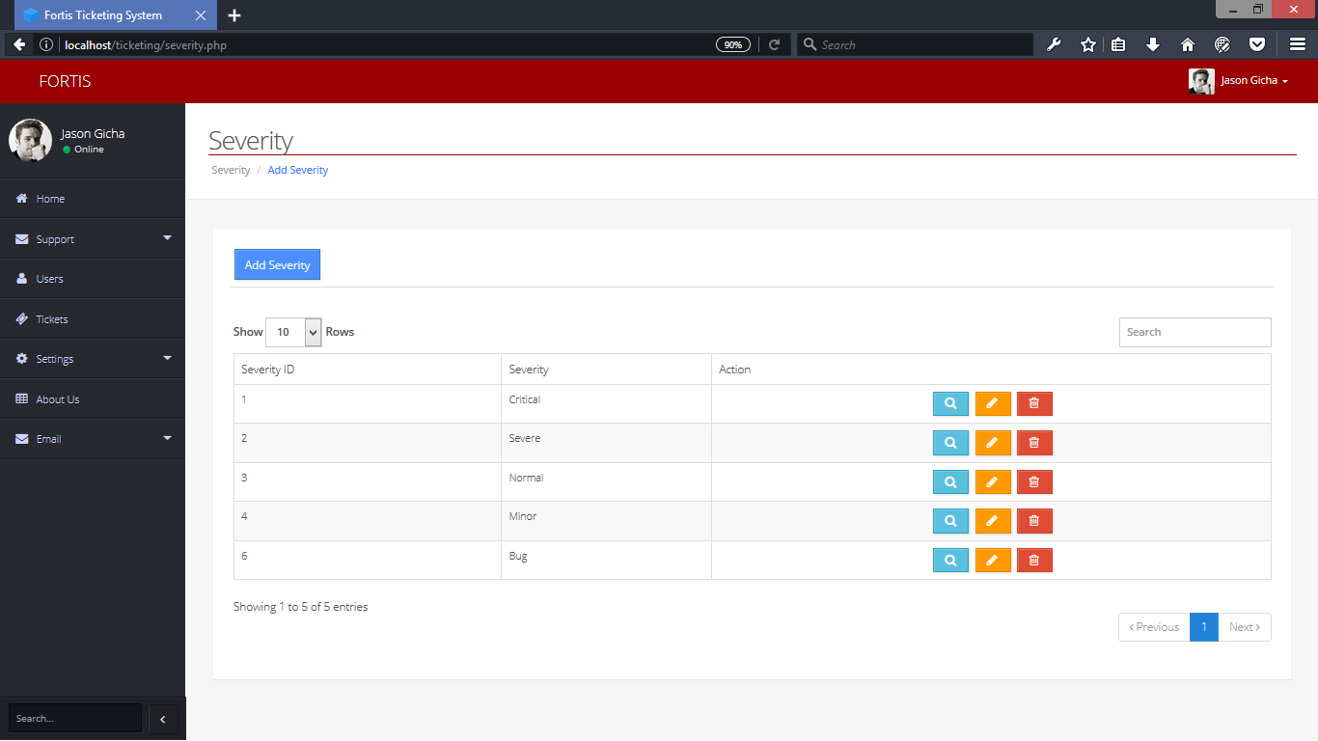

Figure 9.0 Setting Severity
This Setting (Severity) module can add, edit, and delete severity.
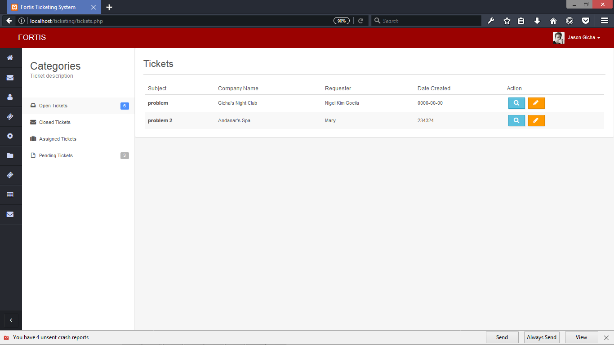
Figure 10.0 Ticket Module
This page is where the users and the administrator can see the status of the tickets and also update the status.
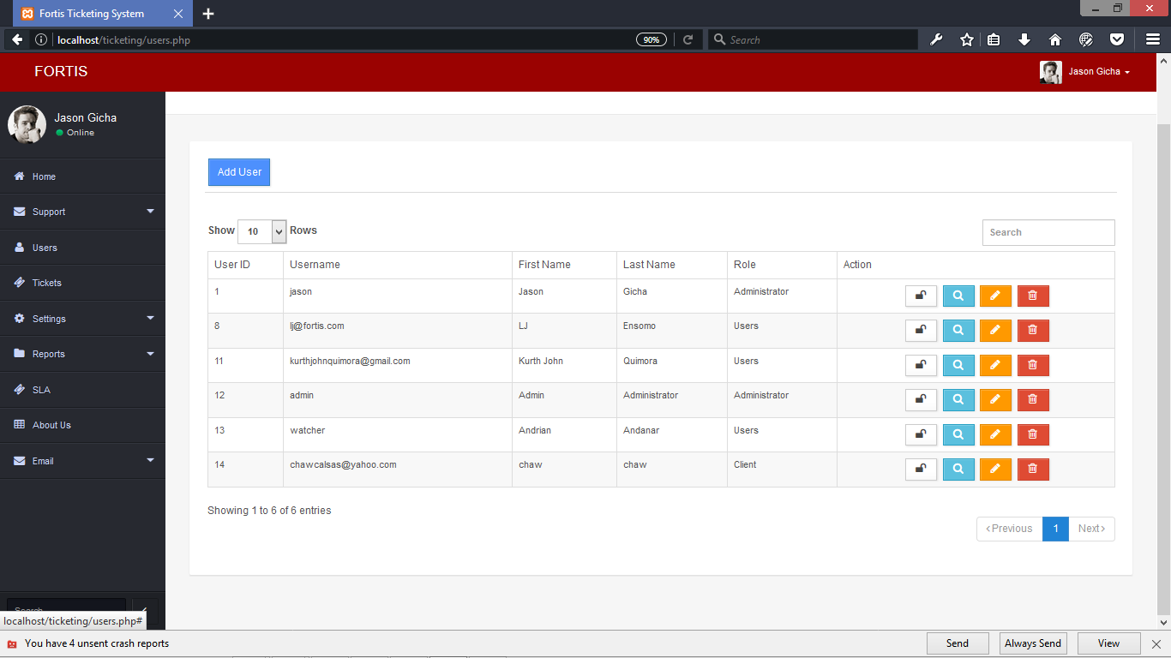
Figure 11.0 Add User
This page let the administrator to add, edit, delete, and lock the accounts of the users.

Implementation Plan
EXPLANATION

Table 1.0 Implementation Plan
STRATEGY | ACTIVITIES | PERSON’S INVOLVED | DURATION
Approval from the Fortis Technologies  Administrator | Letter’s for the Administrator for approval | Researchers, Administrator | 1 Day
System installation | Installation of the system to Fortis Technologies | Researcher’s Administrator | 5 Hours
Information Distribution | User’s guide | Administrator, Developers | 1 Day
Testing | Hands on Training and Lectures | Administrator, Developers | 7 Days

